Complier Lab

Exp. No. 1: Develop a lexical Analyzer to identify identifiers, constants, operators using C program.

Program:

#include<stdio.h>
#include<ctype.h>
#include<string.h>

int main(){
int i,ic=0,m,cc=0,j,oc=0;
char b[30],operators[30],constants[30],identifiers[30];
printf("enter the string: ");
scanf("%[^\n]s",&b);
for(i=0;i<strlen(b);i++){
if(isspace(b[i])){
continue;
}
else if(isalpha(b[i])){
identifiers[ic] = b[i];
ic++;
}
else if(isdigit(b[i])){
m = (b[i]-'0');
i=i+1;
while(isdigit(b[i])){
m=m*10+(b[i]-'0');
i++;
}
i=i-1;
constants[cc] = m;
cc++;
}
else{
if(b[i]=='*'){
operators[oc]='*';
oc++;
}
else if(b[i]=='/'){
operators[oc]='/';
oc++;
}
else if(b[i]=='+'){
operators[oc]='+';
oc++;
}
else if(b[i]=='-'){
operators[oc]='-';
oc++;
}
else if(b[i]=='='){
operators[oc]='=';
oc++;
}
}
}
printf("Identifiers: ");
for(j=0;j<ic;j++){
printf("%c",identifiers[j]);
}
printf("\nConstants: ");
for(j=0;j<cc;j++){
printf("%d",constants[j]);
}
printf("\nOperators: ");
for(j=0;j<oc;j++){
printf("%c",operators[j]);
}
}

Output:
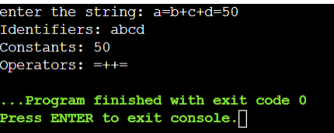

Exp. No. 2: Develop a lexical Analyzer to identify whether a given line is a comment or not using C

Program:

#include<stdio.h>
#include<conio.h>

int main(){
char com[30];
int i=2,a=0;
printf("\nEnter Comment: ");
gets(com);
if(com[0] == '/'){
if(com[1]=='/')
printf("\n It is comment");
else if(com[1]=='*'){
for(i=2;i<=30;i++){
if(com[i]=='*' && com[i+1]=='/'){
printf("\
nIt is a comment");
a=1;
break;
}
else
continue;
}
if(a==0)
printf("\nIt is not a comment");
}
else
printf("\nIt is not a comment");
}
else
printf("\nIt is not a comment");
}

Output:

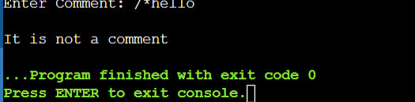

EXP 3: Design a lexical Analyzer for given language should ignore
the redundant spaces, tabs and new lines and ignore comments
using C

Program:
#include <stdio.h>;
#include <stdlib.h>;
#include <string.h>;
#include <ctype.h>;

int isKeyword(char buffer[])
{
char keywords[32][10] =
{"main" , "auto","break","case","char","const","continue","default",
"do","double","else","enum","extern","float","for","goto","if","int",
"long","register","return","short","signed","sizeof","static","struct",
"switch","typedef","unsigned","void","printf","while"};
int i, flag = 0;
for(i = 0; i < 32; ++i)
{
if(strcmp(keywords[i], buffer) == 0)
{
flag = 1;
break;
}
}
return flag;
}

int main()
{

char ch, buffer[15], operators[] = "+-*/%=";
FILE *fp;
int i, j = 0;

fp = stdin;
while((ch = fgetc(fp)) != EOF)
{
for(i = 0; i < 6; ++i)
{
if(ch == operators[i])
printf( "%c is operator\n ", ch);
}

if(isalnum(ch))
{
buffer[j++] = ch;
}
else if((ch == ' ' || ch =='\n') && (j != 0))
{
buffer[j] = '\0';
j = 0;

if(isKeyword(buffer) == 1)
printf( "%s is keyword\n ", buffer);
else
printf( "%s is identifier\n", buffer);
}
}

return 0;
}

OUTPUT:

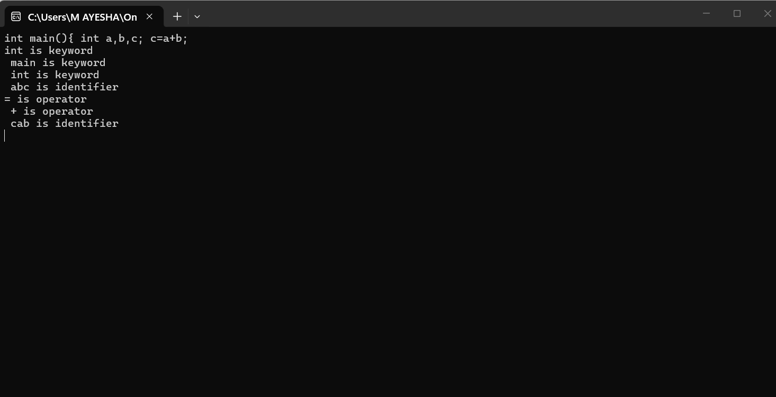

EXP4: Design a lexical Analyzer to validate operators to recognize the operators +,-,*,/ using
regular arithmetic operators using C

Program:

#include <stdio.h>

int main()
{
char s[5];

printf("Enter any operator: ");
scanf("%4s", s);

switch (s[0])
{
case '>':
if (s[1] == '=')
printf("Greater than or equal");
else
printf("Greater than");
break;

case '<':
if (s[1] == '=')
printf("Less than or equal");
else
printf("Less than");
break;

case '=':
if (s[1] == '=')
printf("Equal to");
else
printf("Assignment");
break;

case '!':
if (s[1] == '=')
printf("Not Equal");
else
printf("Logical NOT");
break;

case '&':
if (s[1] == '&')
printf("Logical AND");
else
printf("Bitwise AND");
break;

case '|':
if (s[1] == '|')
printf("Logical OR");
else
printf("Bitwise OR");
break;

case '+': printf("Addition"); break;
case '-': printf("Subtraction"); break;
case '*': printf("Multiplication"); break;
case '/': printf("Division"); break;
case '%': printf("Modulus"); break;

default:
printf("Not an operator");
}

return 0;
}

OUTPUT:
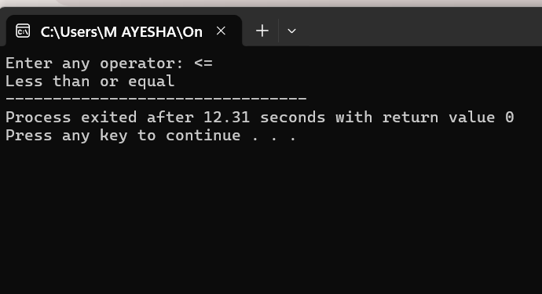

EXP 5:Design a lexical Analyzer to find the number of whitespaces and newline characters.

Program:

#include <stdio.h>
int main()
{
int blank_char,new_line;
blank_char = 0;
new_line = 0;
int c;
printf("Input few words/newlines\n");
for (; (c = getchar()) != EOF;)
{
if(c==' '){
++blank_char;
}
if(c=='\n'){
++new_line;
}
}
printf("blank=%d,newline=%d\n",blank_char,new_line);
} how to stop this code

Output:
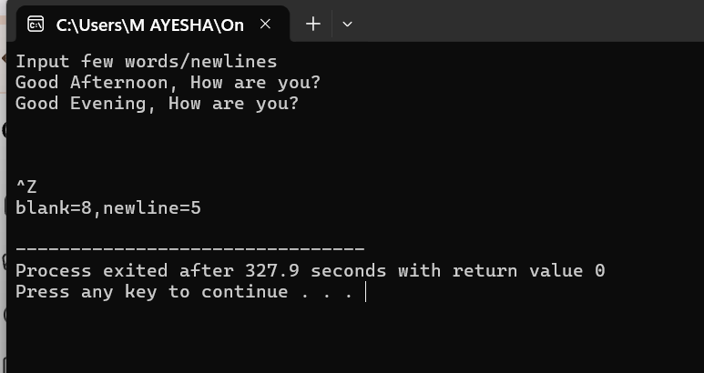

Exp6: Develop a lexical Analyzer to test whether a given identifier is valid or not.

Program:

#include <stdio.h>
#include <ctype.h>
#include <string.h>

int main()
{
char id[100];
int i, valid = 1;

printf("Enter an identifier: ");
scanf("%99s", id);

if (!isalpha(id[0]) && id[0] != '_')
valid = 0;

for (i = 1; id[i] != '\0'; i++)
{
if (!isalnum(id[i]) && id[i] != '_')
{
valid = 0;
break;
}
}

if (valid)
printf("Valid Identifier");
else
printf("Invalid Identifier");

return 0;
}

Output:

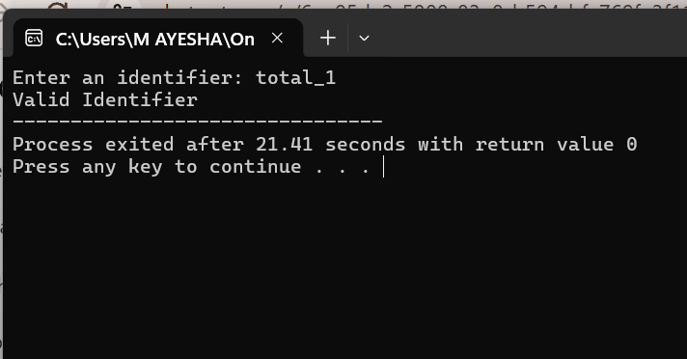

Exp7: Write a C program to find FIRST( ) - predictive parser for the given grammar
S → AaAb / BbBa
A → ∈
B → ∈

Program:
#include<stdio.h>
#include<ctype.h>
void FIRST(char );
int count,n=0;
char prodn[10][10],first[10];
int main()
{
int i,choice;
char c,ch;
printf("How many productions:");
scanf("%d",&count);
printf("Enter %d productions epsilon= $ :\n\n",count);
for(i=0;i<count;i++)
scanf("%s%c",prodn[i],&ch);
do
{
n=0;
printf("Element :");
scanf("%c",&c);
FIRST(c);
printf("\n FIRST(%c)= { ",c);
for(i=0;i<n;i++)
printf("%c ",first[i]);
printf("}\n");
printf("press 1 to continue : ");
scanf("%d%c",&choice,&ch);
}
while(choice==1);
}
void FIRST(char c)
{
int j;
if(!(isupper(c)))
first[n++]=c;
for(j=0;j<count;j++)
{
if(prodn[j][0]==c)
{
if(prodn[j][2]=='$')
first[n++]='$';
else if(islower(prodn[j][2]))
first[n++]=prodn[j][2];
else
FIRST(prodn[j][2]);
}
}
}

Output:
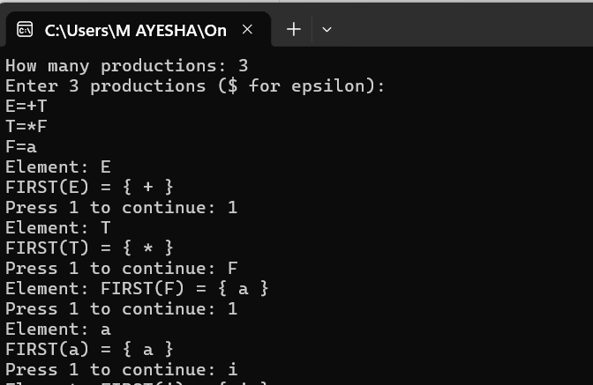

Exp 8:Write a C program to find FOLLOW( ) - predictive parser for the given grammar
S → AaAb / BbBa
A → ∈
B → ∈

Program:

#include<stdio.h>
#include<string.h>
#include<ctype.h>
int n,m=0,p,i=0,j=0;
char a[10][10],f[10];
void follow(char c);
void first(char c);
int main()
{
int i,choice;
char c,ch;
printf("Enter the no.of productions:");
scanf("%d",&n);
printf("Enter the productions(epsilon=@):\n");
for(i=0;i<n;i++)
scanf("%s%c",a[i],&ch);
do
{
m=0;
printf("Enter the element whose FOLLOW is to be found:");
scanf("%c",&c);
follow(c);
printf("FOLLOW(%c) = { ",c);
for(i=0;i<m;i++)
printf("%c ",f[i]);
printf(" }\n");
printf("Do you want to continue(0/1)?");
scanf("%d%c",&choice,&ch);
}
while(choice==1);
}
void follow(char c)
{
if(a[0][0]==c)f[m++]='$';
for(i=0;i<n;i++)
{
for(j=2;j<strlen(a[i]);j++)
{
if(a[i][j]==c)
{
if(a[i][j+1]!='\0')first(a[i][j+1]);

if(a[i][j+1]=='\0'&&c!=a[i][0])
follow(a[i][0]);
}
}
}
}
void first(char c)
{
int k;
if(!(isupper(c)))
f[m++]=c;
for(k=0;k<n;k++)
{
if(a[k][0]==c)
{
if(a[k][2]=='@')
follow(a[i][0]);
else if(islower(a[k][2]))
f[m++]=a[k][2];
else
first(a[k][2]);
}
}
}

Output:
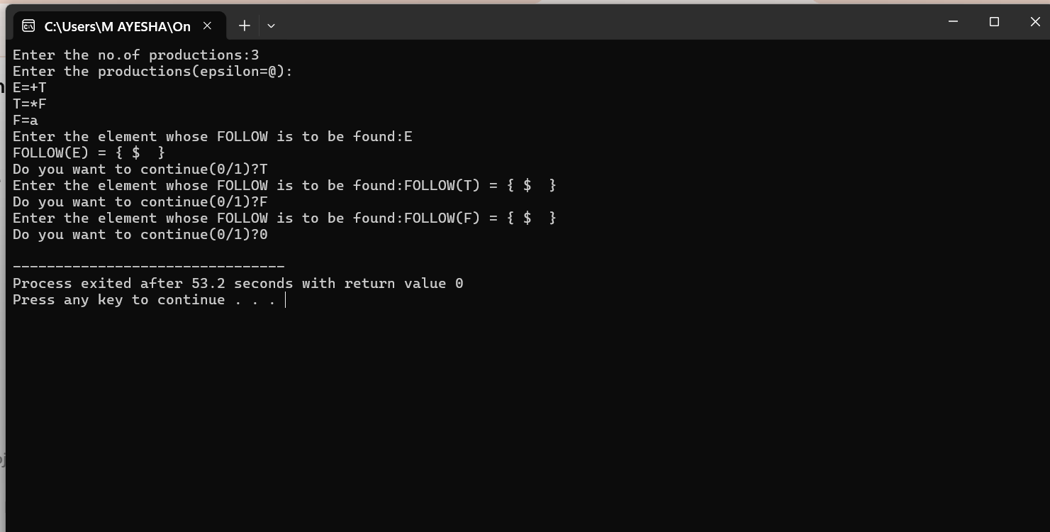

Exp 9: Implement a C program to eliminate left recursion from a given CFG.
S → (L) / a
L → L , S / S

Program:
#include<stdio.h>
#include<string.h>
int main()
{
int n,i,j=0,n1=0,n2=0;
char a[100],b[100],c[200];
printf("Enter production: ");
gets(a);
for(i=3;a[i]!='/';i++,j++)
{
b[j]=a[i];
n1++;
}
i++;
for(j=0;a[i]!='\0';i++,j++)
{
c[j]=a[i];
n2++;
}
printf("%c->",a[0]);
for(i=0;i<strlen(b)||i<strlen(c);i++)
{
if(b[i]!=c[i])
{
break;
}
else
{
printf("%c",b[i]);
}

}
printf("%c'\n%c'->",a[0],a[0]);
j=i;
for(;i<strlen(b);i++)
{
printf("%c",b[i]);
}
printf("/");
for(;j<strlen(c);j++)
{
printf("%c",c[j]);
}

}

Output:
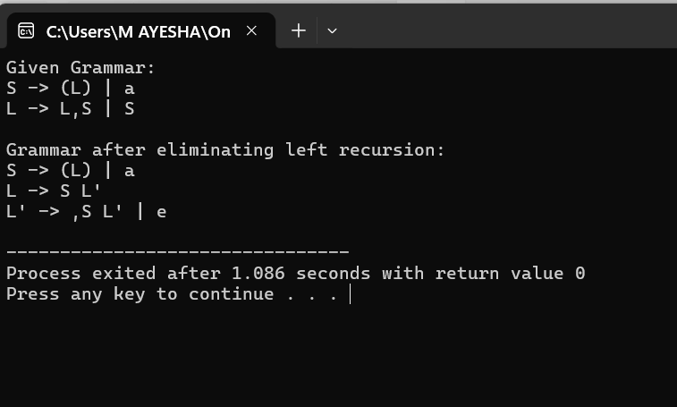

Exp 10: Implement a C program to eliminate left factoring from a given CFG.
S → iEtS / iEtSeS / a
E → b

Program:
#include<stdio.h>
#include<string.h>
int main()
{
int n,i,j=0,n1=0,n2=0;
char a[100],b[100],c[200];
printf("Enter production: ");
gets(a);
for(i=3;a[i]!='/';i++,j++)
{
b[j]=a[i];
n1++;
}
i++;
for(j=0;a[i]!='\0';i++,j++)
{
c[j]=a[i];
n2++;
}
printf("%c->",a[0]);
for(i=0;i<strlen(b)||i<strlen(c);i++)
{
if(b[i]!=c[i])
{
break;
}
else
{
printf("%c",b[i]);
}

}
printf("%c'\n%c'->",a[0],a[0]);
j=i;
for(;i<strlen(b);i++)
{
printf("%c",b[i]);
}
printf("/");
for(;j<strlen(c);j++)
{
printf("%c",c[j]);
}

}

Output:

